**Assignment No 4**

**Name-Aniket Tatoba Mane**

**PRN-2020BTECS00020**

**Batch-B7**

**Subject - CNS LAB**

**Aim**: To implement Railfence cipher

**Theory**: The Rail Fence Cipher is a type of transposition cipher. It works by writing the plaintext in a zigzag pattern across a specified number of lines (rails). The characters are then read off in rows to create the ciphertext. To decrypt, the process is reversed using the same number of rails to reveal the original message.

Code:

#include <bits/stdc++.h>

using namespace std;

string format(string &str)

{

    for (char c : str)

    {

        if (isalpha(c))

        {

            c += tolower(c);

        }

    }

    return str;

}

string encrypt(string &plain, int key)

{

    vector<vector<char>> matrix(key);

    int rowNumber = 0;

    int flag = 1;

    for (int i = 0; i < plain.size(); i++)

    {

        matrix[rowNumber].push_back(plain[i]);

        rowNumber += flag;

        if (rowNumber == 0)

            flag = 1;

        if (rowNumber == key - 1)

            flag = -1;

    }

    string cipher;

    for (int i = 0; i < key; i++)

    {

        for (int j = 0; j < matrix[i].size(); j++)

            cipher += matrix[i][j];

    }

    return cipher;

}

string decrypt(string &cipher, int key)

{

    vector<vector<int>> matrixDecry(key);

    int rowNumber = 0;

    int flag = 1;

    int n = cipher.length();

    for (int i = 0; i < n; i++)

    {

        matrixDecry[rowNumber].push_back(i);

        rowNumber += flag;

        if (rowNumber == (key - 1))

            flag = -1;

        if (rowNumber == 0)

            flag = 1;

    }

    vector<int> mapping;

    for (int i = 0; i < key; i++)

    {

        for (int j = 0; j < matrixDecry[i].size(); j++)

            mapping.push_back(matrixDecry[i][j]);

    }

    map<int, char> m;

    for (int i = 0; i < n; i++)

        m[mapping[i]] = cipher[i];

    string plain;

    for (int i = 0; i < n; i++)

        plain += m[i];

    return plain;

}

int main()

{

    int choice;

    cout << "1. Encrypt\n2. Decrypt\nEnter your choice: ";

    cin >> choice;

    cin.get();

    if (choice == 1)

    {

        string plain;

        int key;

        cout << "\nEnter plain text: ";

        getline(cin, plain);

        plain = format(plain);

        cout << "\nEnter key: integer value(depth): ";

        cin >> key;

        string cipher = encrypt(plain, key);

        cout << "\nEncrypted text is : " << cipher << endl;

    }

    else if (choice == 2)

    {

        string cipher;

        int key;

        cout << "\nEnter cipher text: ";

        getline(cin, cipher);

        cipher = format(cipher);

        cout << "\nEnter key: integer value(depth): ";

        cin >> key;

        string plain = decrypt(cipher, key);

        cout << "\nDecrypted text is : " << plain << endl;

    }

    return 0;

}

Output:

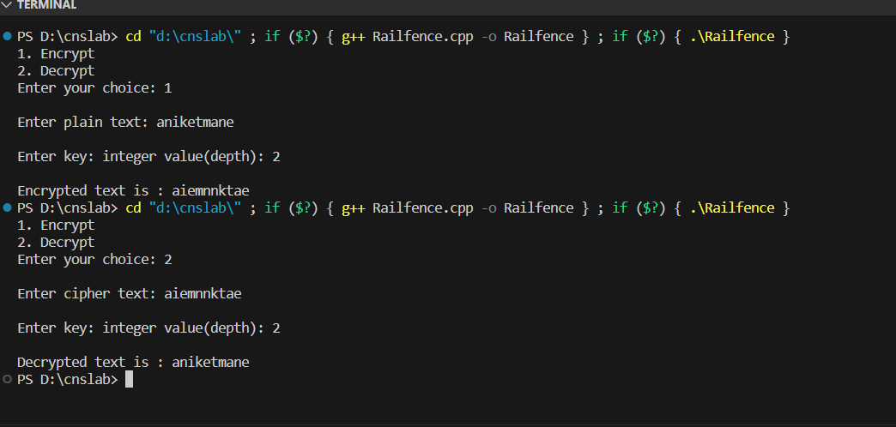

Advantages:

Ease of Understanding: The Rail Fence cipher is straightforward to understand and implement, making it accessible for educational purposes and as a simple encryption technique for casual use.

Speed: Encrypting and decrypting messages using the Rail Fence cipher is relatively fast because it only involves rearranging characters within the message without complex mathematical operations.

Limitations:

Lack of Security: The Rail Fence cipher is not secure against even the most basic cryptographic attacks. With limited rail configurations and easily discernible patterns in the ciphertext, it is vulnerable to brute force attacks and frequency analysis.

Predictable Patterns: The Rail Fence cipher produces patterns in the ciphertext that are easily recognizable. An attacker can quickly deduce the number of rails used, leading to a faster decryption process.

**Aim**: To implement Columnar cipher

**Theory**: The Columnar Cipher is a transposition cipher where the plaintext is written out in rows and then read out again column by column in sorted order of characters in key. The key determines the number of columns.

Code:

#include <bits/stdc++.h>

using namespace std;

string alpha_lower(string text)

{

    for (char c : text)

    {

        if (isalnum(c))

        {

            c = tolower(c);

        }

    }

    return text;

}

string encrypt(string text, string key)

{

    map<char, vector<char>> mp;

    int cnt = 0;

    for (int i = 0; i < text.size(); i++)

    {

        if (cnt == key.size())

            cnt = 0;

        mp[key[cnt++]].push_back(text[i]);

    }

    string encrypted;

    for (auto i : mp)

    {

        for (auto j : i.second)

        {

            encrypted += j;

        }

    }

    return encrypted;

}

string decrypt(string cipher, string key)

{

    map<int, int> map1;

    int common = cipher.size() / key.size();

    int extra = cipher.size() % key.size();

    for (int i = 0; i < key.size(); i++)

    {

        if (i < extra)

            map1[i] = common + 1;

        else

            map1[i] = common;

    }

    map<int, vector<char>> map2;

    int start = 0;

    string sortedKey = key;

    sort(sortedKey.begin(), sortedKey.end());

    for (int i = 0; i < sortedKey.size(); i++)

    {

        for (int j = 0; j < key.size(); j++)

        {

            if (sortedKey[i] == key[j])

            {

                for (int k = 0; k < map1[j]; k++)

                {

                    map2[key[j]].push_back(cipher[start++]);

                }

            }

        }

    }

    string plain;

    vector<int> counters(key.size(), 0);

    while (plain.size() < cipher.size())

    {

        for (int i = 0; i < key.size(); i++)

        {

            if (counters[i] < map1[i])

                plain += map2[key[i]][counters[i]++];

        }

    }

    return plain;

}

int main()

{

    int choice;

    cout << "Enter choice: ";

    cout << endl

         << "1. Encrypt | 2. Decrypt" << endl;

    cin >> choice;

    cin.get();

    if (choice == 1)

    {

        string text, key;

        cout << "\nEnter text: ";

        getline(cin, text);

        text = alpha_lower(text);

        cout << "\nEnter key: ";

        getline(cin, key);

        alpha_lower(key);

        string cipher = encrypt(text, key);

        cout << "\nEncrypted text is : " << cipher << endl;

    }

    else if (choice == 2)

    {

        string cipher, key;

        cout << "\nEnter cipher text: ";

        getline(cin, cipher);

        cipher = alpha_lower(cipher);

        cout << "\nEnter key: ";

        getline(cin, key);

        alpha_lower(key);

        string text = decrypt(cipher, key);

        cout << "\nDecrypted text is : " << text << endl;

    }

    return 0;

}

Output:

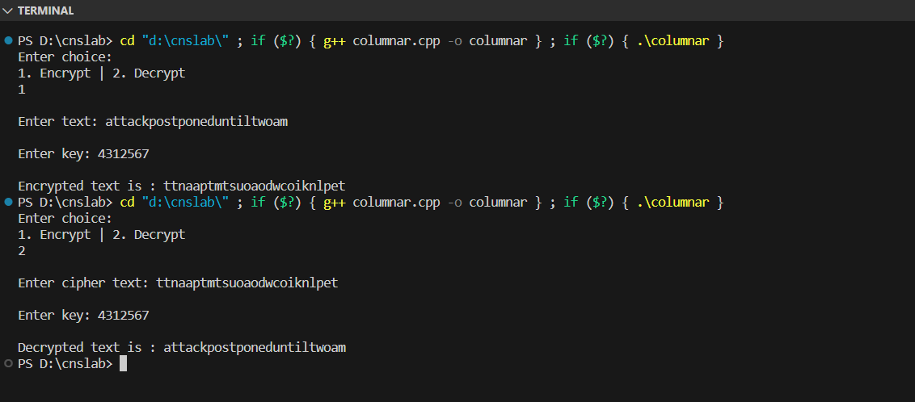

Advantages:

Key-Dependent Security: The Columnar Cipher's security is heavily dependent on the choice of the key, which determines the arrangement of letters in the grid. If a strong and random key is used, it can provide a reasonable level of security.

Simplicity: The Columnar Cipher is relatively simple to understand and implement. It does not involve complex mathematical operations or require large key sizes, making it accessible for educational purposes and simple cryptographic tasks.